**Factory Pattern**

Program:

import java.util.Scanner;

interface Document

{

    public void createDocument();

}

interface  WordDocument extends Document

{

    public void createDocument();

}

interface PdfDocument extends Document

{

    public void createDocument();

}

interface ExcelDocument extends Document

{

    public void createDocument();

}

class WordImplementation implements WordDocument{

    @Override

    public void createDocument()

    {

        System.out.println("This is processed information from Word document");

    }

}

class ExcelImplementation implements ExcelDocument

{

    @Override

    public void createDocument()

    {

        System.out.println("This is processed information from Excel document");

    }

}

class PDFImplementation implements PdfDocument

{

    @Override

    public void createDocument()

    {

        System.out.println("This is processed information from PDF document");

    }

}

public class DocumentFactory {

    public static void main(String[] args) {

        Scanner sc = new Scanner(System.in);

        System.out.println("Enter the document you want to crete \n1.Word\n2.PDF\n3.Excel");

        int s = sc.nextInt();

        Document d = null;

        switch (s) {

            case 1:

                d = new WordImplementation();

                break;

            case 2:

                d = new PDFImplementation();

                break;

            case 3:

                d = new ExcelImplementation();

                break;

            default:

                System.out.println("Enter a valid choice please");

        }

        if(d != null)

            d.createDocument();

    }

}

**Output:**

From Word:

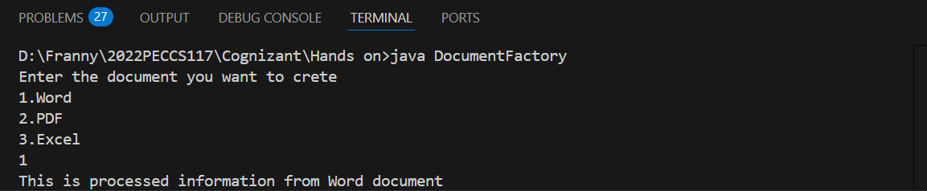

From PDF:

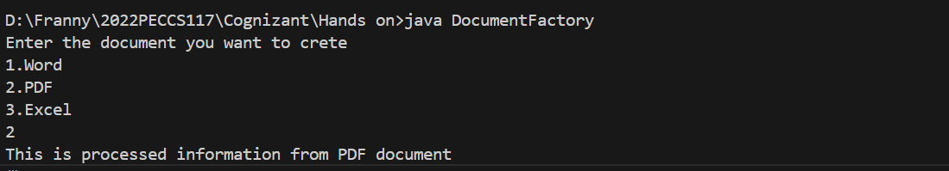

From Excel:

